THE UNIVERSITY OF BAMENDA

DEPARTMENT OF COMPUTER ENGINEERING
THE COLLEGE OF
TECHNOLOGY

DESIGN AND IMPLEMENTATION OF A WEB-BASED WATER QUALITY MONITORING SYSTEM FOR LOCAL COMMUNITIES IN BAMENDA, CAMEROON

A Project Submitted to the Department of Computer Engineering in the
College of Technology of the University of Bamenda in Partial Fulfillment of the Requirements for the Award of a Bachelor of Technology in Computer Networks and System Maintenance

BY:
Name
TEYIM YANICK NJIGMESHI
Registration Number:
UBA23PH049
SUPERVISOR:
Dr. ATANGANA OTELE
2025/2026

ABSTRACT
Access to safe and clean water remains a major challenge in many local communities in Bamenda, Cameroon. This project presents the design and implementation of a web-based water quality monitoring system aimed at supporting local communities, councils, and non-governmental organizations (NGOs) in monitoring and managing water quality. The system allows community members to manually submit water quality observations and test results through a web application, creating a centralized and accessible platform for water quality data collection.
The application is developed using PHP (Laravel), HTML, CSS, and JavaScript, and provides features such as user authentication, water source registration, data visualization, and status reporting. Councils can verify the condition of water sources within their jurisdiction, while NGOs can use the collected data to provide recommendations for improving water quality. The system is designed to operate effectively under intermediate internet conditions common in Bamenda, with future support for sensor-based data integration beyond the scope of this project.
The proposed solution enhances community participation, improves access to water quality information, and supports informed decision-making to promote public health and environmental sustainability.

DEDICATION
This project is dedicated to my parents, whose continuous support, guidance, and encouragement have been a source of motivation throughout my academic journey.

ACKNOWLEDGEMENT
I sincerely express my gratitude to Central University Bamenda and all its staff for the knowledge and academic foundation provided throughout my studies. I also extend my sincere appreciation to my project supervisor for his guidance, encouragement, and valuable advice, which greatly contributed to the successful completion of this project.
My profound gratitude goes to my parents and family members for their moral, emotional, and financial support throughout my academic journey. I also thank my friends and classmates for their encouragement and assistance in one way or another. Above all, I thank the Almighty God for the gift of life, strength, and wisdom throughout the execution of this project.

TABLE OF CONTENT

ABSTRACT 2
DEDICATION 3
ACKNOWLEDGEMENT 4
CHAPTER ONE 8
INTRODUCTION 8
1.1 Context (Background of the Study) 8
1.2 Problem Statement 9
1.3 Research Questions 9
1.3.1 General Research Question 9
1.3.2 Specific Research Questions 9
1.4 Objectives of the Study 10
1.4.1 General Objective 10
1.4.2 Specific Objectives 10
1.5 Justification and Motivation 10
1.6 Significance of the Study 10
1.7 Scope 11
1.8 Limitations 11
1.9 Delimitations 12
CHAPTER TWO 13
LITERATURE REVIEW 13
2.1 Introduction 13
2.2 Water Service Disruption Management 13
2.3 Web-Based Reporting Systems for Infrastructure Issues 14
2.4 Community-Based Reporting Approaches 14
2.5 Role of Water Companies and Service Providers 15
2.6 Geographic Information Systems (GIS) and Live Location Mapping 15
2.7 Gaps in Existing Studies 16
2.8 Summary of Literature Review 17
CHAPTER THREE 18
3.0 RESEARCH METHODOLOGY AND SYSTEM DESIGN 18
3.1 Introduction 18
3.2 Justification for Design Science Approach 18
3.3 Requirements Gathering 19
3.3.1 Data Collection Methods 19
3.3.2 Functional Requirements 19
3.3.3 Non-Functional Requirements 19
3.4 System Architecture 20
3.4.1 Architectural Overview 20
3.4.2 Presentation Tier (Frontend) 21
3.4.3 Application Tier (Backend) 21
3.4.4 Data Tier (Database) 22
3.5 Database Design 23
3.5.1 Table Structures 23
3.6 User Interface Design 24
3.6.1 Design Principles 24
3.6.2 Color Scheme 24
3.6.3 Screen Designs and Wireframes 25
3.7 Processing Logic and Algorithms 27
3.7.1 Safety Status Calculation Algorithm 27
3.8 Development Methodology 28
3.8.1 Selection of Agile Methodology 28
3.8.2 Iteration Structure 29
3.9 Development Tools and Environment 29
3.9.1 Hardware Environment 29
3.9.2 Software Development Tools 29
3.9.3 Technology Stack Summary 30
3.10 Ethical Considerations 31
3.10.1 Data Privacy and Protection 31
3.10.2 Informed Consent 31
3.10.3 Data Accuracy and Transparency 32
3.11.1 Use Case Diagram 32
3.11.2 Class Diagram 33
3.11.3 Entity Relationship Diagram 34
3.12 Summary 35
REFERENCES 36

LIST OF FIGURES

Figure 3.1: Three-Tier System Architecture Diagram showing the Presentation 17
Figure 3.2: API Endpoint Structure Diagram showing the relationship between HTTP methods 18
Figure 3.3: Entity-Relationship Diagram showing the six main tables 19
Table 3.1: Color Scheme Reference showing each color name, hex code 21
Figure 3.6: Home Page Wireframe showing the layout with header, map area, legend, control panel with filters and search, and statistics bar. 22
Figure 3.9: Pseudocode for Safety Status Calculation Algorithm showing the step-by-step logic in programming-like syntax. 24
Table 3.3: Complete Technology Stack showing each layer (Frontend, Backend, Database, Tools), the specific technology chosen, version number, and justification for selection. 27
Figure 3.11: Use Case Diagram showing all five actors (Local Resident, Registered User, Data Entry Clerk, Health Worker, Administrator) 29
Figure 3.12: Class Diagram showing the six main classes with their attributes and methods, along with association lines indicating relationships and multiplicities 30
Figure 3.13: Entity Relationship Diagram showing the six tables 31

CHAPTER ONE

INTRODUCTION

1.1 Context (Background of the Study)
Access to reliable water supply is fundamental to human health, daily living, and economic activity. In many parts of Cameroon, particularly in the North West Region and the city of Bamenda, residents depend on pipe-borne water systems managed by water companies. These systems deliver water to households, businesses, and public facilities through an extensive network of pipes, taps, and distribution points.
However, water service disruptions are a daily reality for many residents in Bamenda. These disruptions take multiple forms: burst pipes that leak water for days without repair, sudden water cuts with no explanation, and service suspensions due to unpaid bills. When a pipe bursts, water is wasted, roads are damaged, and nearby households lose access to supply. When water is cut without warning, residents do not know whether the cause is a technical fault, planned maintenance, or a billing issue. This confusion leads to frustration, wasted time, and delayed resolution.
Currently, there is no centralized or functional system for residents to report these disruptions directly to water companies. In some cases, residents must call phone numbers that are rarely answered. In other cases, they must travel to water company offices to complain. Some residents simply wait, hoping the problem will fix itself. Water companies, on the other hand, lack a structured way to receive, track, and respond to citizen reports. Repair teams may not know where bursts are located. Bill collectors have no way to communicate with customers about overdue payments before cutting water supply.
With the growing availability of internet services and the widespread use of mobile phones in Bamenda, a web-based platform offers a practical solution to this challenge. Such a platform can provide a centralized space where community members report water service disruptions using live location mapping, and water company staff can view, manage, and respond to these reports in real time. This project focuses on designing and implementing a web-based water service disruption reporting system tailored to the needs of local communities and water companies in Bamenda, Cameroon.

1.2 Problem Statement
Despite the importance of reliable water supply, water service disruption management in Bamenda remains inadequate, unstructured, and fragmented. There is no centralized web-based platform that allows community members to report disruptions such as burst pipes, unexplained water cuts, or bill-related suspensions directly to water companies using live location mapping.
As a result, residents face multiple challenges. Burst pipes may leak for days or weeks because no one knows how to report them effectively. When water is cut, residents often cannot determine the cause—whether it is a technical fault, planned maintenance, or an unpaid bill. Those whose water is suspended due to unpaid bills may not receive any warning or clear information on how to restore service. Water companies struggle to prioritize repairs because they lack real-time data on the location and severity of disruptions. Plumbers and repair teams waste time searching for reported problems due to inaccurate or missing location information. Bill collectors have no efficient way to notify customers before service suspension.
The key problem addressed by this study is the lack of a localized, affordable, web-based system that enables community members to report water service disruptions with live location data and enables water companies to receive, manage, and respond to these reports efficiently.

1.3 Research Questions

1.3.1 General Research Question
How can a web-based application be used to improve the reporting and management of water service disruptions in local communities in Bamenda?

1.3.2 Specific Research Questions
- How can community members report water service disruptions (burst pipes, no water flow, bill-related suspensions) through a web platform with live location capture?
- How can water companies (plumbers, bill collectors, customer service staff) receive, manage, and respond to reported disruptions using a centralized dashboard?
- How can the system provide residents with transparency and status updates on their reported issues?

1.4 Objectives of the Study

1.4.1 General Objective
To design and implement a web-based water service disruption reporting system that supports community members and water companies in managing water service disruptions in Bamenda, Cameroon.

1.4.2 Specific Objectives
- To examine existing water disruption reporting practices in local communities in Bamenda.
- To design a user-friendly web application for manual submission of water disruption reports with automatic live location capture.
- To develop a centralized database for storing and managing water disruption records, including report status and resolution tracking.

1.5 Justification and Motivation
This project is motivated by the daily struggles of Bamenda residents who face water disruptions without any effective means of reporting them. It is also motivated by the challenges water companies face in receiving accurate, location-based information from the communities they serve.
Unlike expensive sensor-based systems that are unaffordable for local contexts, this project uses basic web and mobile technologies that are already accessible to most residents. By building a simple, map-based reporting platform, this project aims to bridge the communication gap between communities and water companies, leading to faster response times, reduced water loss from burst pipes, and improved transparency around water service interruptions—including those related to bill payments.

1.6 Significance of the Study
The system will provide the following benefits:
Stakeholder | Benefit
Community Members | A simple way to report water disruptions with automatic location capture; ability to track the status of their reports; transparency about whether water cuts are due to technical issues or billing problems
Water Companies (Plumbers, Bill Collectors, Customer Service) | A centralized dashboard to receive and manage reports; accurate location data to guide repair teams; ability to communicate with residents about bill-related suspensions
Local Government Regulators | Data on recurring disruptions to inform infrastructure investment decisions

1.7 Scope
This project focuses on the development of a web-based water service disruption reporting system for Bamenda, Cameroon. The system allows community members to submit reports manually through a web application with live location mapping. Water company staff can view, update, and resolve reports through a secure dashboard. The scope includes the following disruption types:
- Burst pipes
- No water flow (unexplained cuts)
- Water suspension due to unpaid bills
- Other water service disruptions
The project excludes real-time sensor integration, automated water quality testing, and mobile SMS-based reporting.

1.8 Limitations
One of the major limitations of this study is its dependence on internet connectivity, which may be inconsistent in some parts of Bamenda and surrounding communities, thereby affecting timely access to the web application. In addition, the system relies on manually submitted data from community members, which may vary in accuracy due to differences in users' knowledge, honesty, or ability to correctly identify disruption types. Live location capture depends on the availability of GPS on the user's device, which may not be present on all mobile phones. Furthermore, the system does not automatically verify whether a reported burst pipe or water cut is genuine, relying instead on water company staff to validate reports. These limitations may influence the completeness and reliability of the data collected; however, the system is designed to mitigate these challenges through structured data entry forms and verification by water company staff.

1.9 Delimitations
This study is deliberately limited in scope to Bamenda and nearby local communities in the North West Region of Cameroon in order to ensure relevance and manageability at the Bachelor level. The project focuses exclusively on the development of a web-based water service disruption reporting application using manual data entry with live location mapping. It does not include the design or implementation of physical sensors, automated water quality testing, or integration with water company billing systems. The system addresses reporting and tracking of water service disruptions rather than direct repair of infrastructure or water bill payment processing. These delimitations allow the study to concentrate on addressing local communication challenges between communities and water companies using web technologies while providing a foundation for future expansion.

CHAPTER TWO

LITERATURE REVIEW

2.1 Introduction
This chapter reviews existing literature related to water service disruption management, web-based reporting systems, community-driven data collection approaches, geographic information systems (GIS) for infrastructure reporting, and the role of water companies in customer communication. The review establishes the theoretical and practical background of the study and highlights gaps in existing research that justify the need for a localized, web-based water service disruption reporting system for communities and water companies in Bamenda, Cameroon.

2.2 Water Service Disruption Management
Water service disruption refers to any interruption in the delivery of piped water to households, businesses, or public facilities. According to the World Health Organization (2024), reliable water supply is essential for public health, hygiene, and economic activity. Disruptions can take multiple forms, including infrastructure failures (burst pipes), operational issues (maintenance), and administrative actions (service suspension due to unpaid bills).
Burst Pipes: Burst pipes are among the most common causes of water service disruption in urban and semi-urban areas. A study by Tchoupo et al. (2022) in Douala, Cameroon, found that aging infrastructure, poor maintenance, and road construction activities were the primary causes of pipe bursts. The study also noted that burst pipes often go unreported for days or weeks because residents lack an effective reporting mechanism, leading to significant water loss and property damage.
Unexplained Water Cuts: In many Cameroonian cities, residents frequently experience sudden water cuts without any notification or explanation. Nkeng and Elambo (2021) surveyed households in Bamenda and found that over 60% of respondents had experienced at least three unexplained water cuts in the preceding month. The lack of communication from water companies leaves residents confused about whether the disruption is due to a technical fault, planned maintenance, or a billing issue.
Bill-Related Service Suspension: Water companies commonly suspend service when customers fail to pay their bills on time. However, research by Mbaku (2023) in the North West Region of Cameroon revealed that many residents receive no prior warning before their water is cut. Furthermore, residents often do not know how to resolve the suspension quickly or who to contact. This lack of transparency creates frustration and mistrust between water companies and the communities they serve.

2.3 Web-Based Reporting Systems for Infrastructure Issues
Web-based information systems have increasingly been adopted for reporting public infrastructure problems such as potholes, broken streetlights, and water leaks. These systems allow citizens to report issues through an internet-enabled platform, which is then stored in a centralized database and made accessible to relevant authorities.
Global Examples: In the United States, platforms like SeeClickFix and 311 services enable residents to report non-emergency infrastructure issues directly to local governments (Johnson & Martinez, 2021). In Kenya, the MajiVoice platform allows citizens to report water service problems to utility companies via web and mobile interfaces (Otieno & Wanjiru, 2022). These platforms have demonstrated improved response times and increased citizen satisfaction.
Applicability to Cameroon: Despite the success of such platforms elsewhere, similar systems are largely absent in Cameroon. A review by Fombu and Ndeh (2023) found that while several pilot projects have been attempted in Yaoundé and Douala, none have been sustained or scaled to cities like Bamenda. The authors attributed this to lack of funding, poor internet infrastructure, and absence of local technical expertise.

2.4 Community-Based Reporting Approaches
Community-based reporting involves the active participation of local residents in identifying and reporting service delivery problems. Several studies emphasize that involving communities in reporting increases coverage, promotes civic engagement, and encourages a sense of ownership over local infrastructure (Chambers, 2018; Cornwall & Gaventa, 2021).
Citizen Reporting in Water Services: In the water sector, community-based reporting has been used to identify leaks, burst pipes, and illegal connections. A study by Akinyemi and Adebayo (2022) in Lagos, Nigeria, found that community members who were given a simple mobile reporting tool reported 45% more water infrastructure faults than areas relying on official inspections alone.
Challenges: However, effective community-based reporting requires simple, user-friendly systems to ensure participation and data reliability. Nwachukwu et al. (2023) noted that many reporting systems fail because they assume high levels of literacy, smartphone access, and internet connectivity, which are not always available in African communities. Therefore, systems designed for contexts like Bamenda must be lightweight, mobile-friendly, and accessible to users with basic phones.

2.5 Role of Water Companies and Service Providers
Water companies in Cameroon, including CAMWATER and various municipal utilities, are responsible for managing water distribution, maintaining infrastructure, collecting bills, and responding to customer complaints. However, research indicates that these companies face significant challenges in customer communication and service disruption management (Ngwa & Ako, 2022).
Customer Communication Gaps: A survey by Ewane and Fonyuy (2023) of water company staff in the North West Region found that most customer complaints are still received by phone or in-person visits. No centralized digital system exists for logging, tracking, or responding to reports. As a result, complaints are often lost, forgotten, or delayed.
Bill Collection and Suspension Processes: Bill collection is a critical function of water companies, yet it is often disconnected from customer communication systems. Tchinda and Nana (2021) found that water companies in Cameroon typically send paper bills or SMS reminders, but these messages may not reach customers due to incorrect contact information or network issues. When bills remain unpaid, service is suspended—often without final warning—leaving customers confused and frustrated.
Plumbers and Repair Teams: Repair teams responsible for fixing burst pipes and restoring water flow often operate without accurate location data. A study by Mbah and Ndum (2022) revealed that plumbers in Bamenda waste an average of 2-3 hours per day searching for reported burst pipes because residents provide vague or incorrect location descriptions. This delay prolongs water loss and extends the duration of service disruption.

2.6 Geographic Information Systems (GIS) and Live Location Mapping
Geographic Information Systems (GIS) and live location mapping technologies have revolutionized infrastructure reporting by enabling precise location capture and visualization. When citizens report an issue, their device's GPS can automatically capture latitude and longitude coordinates, eliminating the need for vague verbal descriptions (Goodchild, 2018).
Map-Based Reporting: Platforms such as Ushahidi (originally developed in Kenya) and Mapillary have demonstrated the power of map-based citizen reporting. Users can pin issues on a map, add photos and descriptions, and view previously reported issues in their area (Okolloh, 2019).
Integration with Water Services: In the water sector, location mapping has been used to track leak reports, identify recurring burst pipe locations, and guide repair teams. A study by Mwangi and Karanja (2022) in Nairobi, Kenya, implemented a map-based water fault reporting system and reduced average response time from 72 hours to 24 hours. The key success factor was automatic location capture, which eliminated the need for users to describe where the problem was located.
Feasibility for Bamenda: With the widespread availability of smartphones and GPS in Bamenda, live location mapping is technically feasible. However, researchers caution that systems should include a manual location adjustment feature, as GPS accuracy can vary, and some users may prefer to correct the pin location (Nformi & Che, 2023).

2.7 Gaps in Existing Studies
Although several studies have explored water service disruption reporting systems, significant gaps remain.
Gap | Description
No localized system for Bamenda | Most existing research focuses on other African cities (Nairobi, Lagos, Cape Town). No study has documented the design, implementation, or evaluation of a water disruption reporting system specifically for Bamenda, Cameroon.
Bill suspension not addressed | Existing reporting systems focus on infrastructure faults (burst pipes, leaks) but rarely include bill-related service suspension as a reportable issue. This is a major gap because many water cuts in Cameroon are bill-related.
Integration of multiple disruption types | Most systems address only one type of disruption (e.g., burst pipes only). No system found in the literature comprehensively addresses burst pipes, unexplained cuts, and bill-related suspensions in a single platform.
Water company dashboard lacking | Many citizen reporting systems collect data but do not provide a functional dashboard for service providers to manage and respond to reports. This limits the system's usefulness for water companies.
Limited attention to local technology constraints | Many proposed systems assume high-speed internet and latest smartphones. Few studies address the reality of low-bandwidth connections and basic devices common in Bamenda.

2.8 Summary of Literature Review
The literature reviewed demonstrates that water service disruptions—including burst pipes, unexplained cuts, and bill-related suspensions—are significant problems in Cameroonian cities, particularly Bamenda. While web-based citizen reporting systems have been successfully implemented elsewhere for infrastructure issues, no such system exists for water service disruptions in Bamenda.
The review also highlights the importance of community participation, live location mapping, and water company dashboards for effective disruption management. Furthermore, it identifies a critical gap: existing systems and studies rarely address bill-related service suspension as a reportable issue.
This study seeks to address these gaps by designing and implementing WataReport, a web-based water service disruption reporting system that:
- Allows community members to report burst pipes, unexplained water cuts, and bill-related suspensions
- Captures live location data automatically
- Provides a dashboard for water company staff (plumbers, bill collectors, customer service)
- Is optimized for the technological conditions (low bandwidth, basic smartphones) of Bamenda, Cameroon

CHAPTER THREE

3.0 RESEARCH METHODOLOGY AND SYSTEM DESIGN

3.1 Introduction
This chapter presents the research methodology and system design for the Bamenda Water & Health Dashboard, a web-based water quality monitoring system for Mankon, Bamenda, Cameroon. It describes the research approach, requirements gathering methods, system architecture, database design, user interface design, development methodology, tools, testing strategy, deployment plan, and ethical considerations, translating stakeholder requirements into a concrete technical blueprint ready for implementation.
The study adopts a Design Science Research Methodology (DSRM), which focuses on creating and evaluating technological artifacts to solve real-world problems. This approach was selected because the primary outcome is a functioning web application addressing inadequate water quality monitoring in Mankon. DSRM consists of five sequential phases: problem identification and motivation from Chapter One, definition of solution objectives based on stakeholder needs, design and development as the focus of this chapter, demonstration through implementation, and evaluation through testing and user feedback. This methodology was chosen because it is problem-oriented, emphasizes rigorous evaluation, is widely accepted in computer science research, and provides clear structure appropriate for a bachelor's degree project

3.2 Justification for Design Science Approach
Alternative research methodologies were considered but found less suitable for this project. A pure survey methodology would describe existing conditions but would not produce a solution to improve them. An experimental methodology would test hypotheses under controlled conditions but would not address the specific contextual needs of Mankon. A case study approach would provide in-depth understanding of a single situation but would not result in a transferable artifact. The design science approach was therefore selected because it combines understanding of the problem domain with the creation of a practical solution, which aligns perfectly with the project's objectives of designing and implementing a functional web-based monitoring system.

3.3 Requirements Gathering

3.3.1 Data Collection Methods
Requirements were gathered through three complementary methods. Document analysis of NGO reports and Ministry publications revealed that water quality information exists only in scattered paper records that communities never see, confirming the need for a centralized digital platform. Stakeholder analysis identified primary actors including local residents, water point committee members, health workers, data entry clerks, and administrators, as well as secondary actors such as public health officials, NGO officers, researchers, and donors, with each actor's goals and pain points documented to derive functional requirements. Contextual inquiry revealed that community members already make sensory observations about water quality but lack a channel to report these findings to authorities.

3.3.2 Functional Requirements
Based on the requirements gathering activities, the following functional requirements were defined. The system must provide an interactive map showing all water sources in Mankon with color-coded pins indicating safety status. Users must be able to click on any pin to view detailed information about that water source including its name, location, type, test history, and community reports. Community members must be able to submit water quality observations through a simple mobile-friendly form that requires minimal typing. Authorized data entry personnel must be able to add official test results from laboratory analysis. Administrators must be able to moderate community reports, manage water source information, and manage user accounts. Health workers must be able to submit weekly disease case data for their facilities. All users must be able to view dashboard statistics and charts showing water quality trends.

3.3.3 Non-Functional Requirements
Non-functional requirements define quality attributes of the system. For performance, the page load time must be under three seconds on a 3G network connection, the map must load within five seconds, the API must respond within five hundred milliseconds, and the system must support fifty concurrent users. For usability, the system must be fully functional on smartphones with screens as small as 320 pixels, must work acceptably on low-bandwidth connections through optimized images and minimal JavaScript, and must follow accessibility guidelines. For security, all passwords must be hashed using bcrypt, all production traffic must be encrypted using HTTPS, all user inputs must be validated and sanitized, and API endpoints must have rate limiting to prevent abuse. For reliability, the system must maintain ninety-nine percent uptime during operational hours and have daily automated database backups.

3.4 System Architecture

3.4.1 Architectural Overview
The Bamenda Water & Health Dashboard follows a three-tier client-server architecture consisting of a presentation tier, an application tier, and a data tier. This architectural pattern was selected because it separates concerns, improves maintainability, allows each tier to be scaled independently, and is widely supported by web hosting services. The separation between frontend and backend also enables future mobile application development that could reuse the same API.

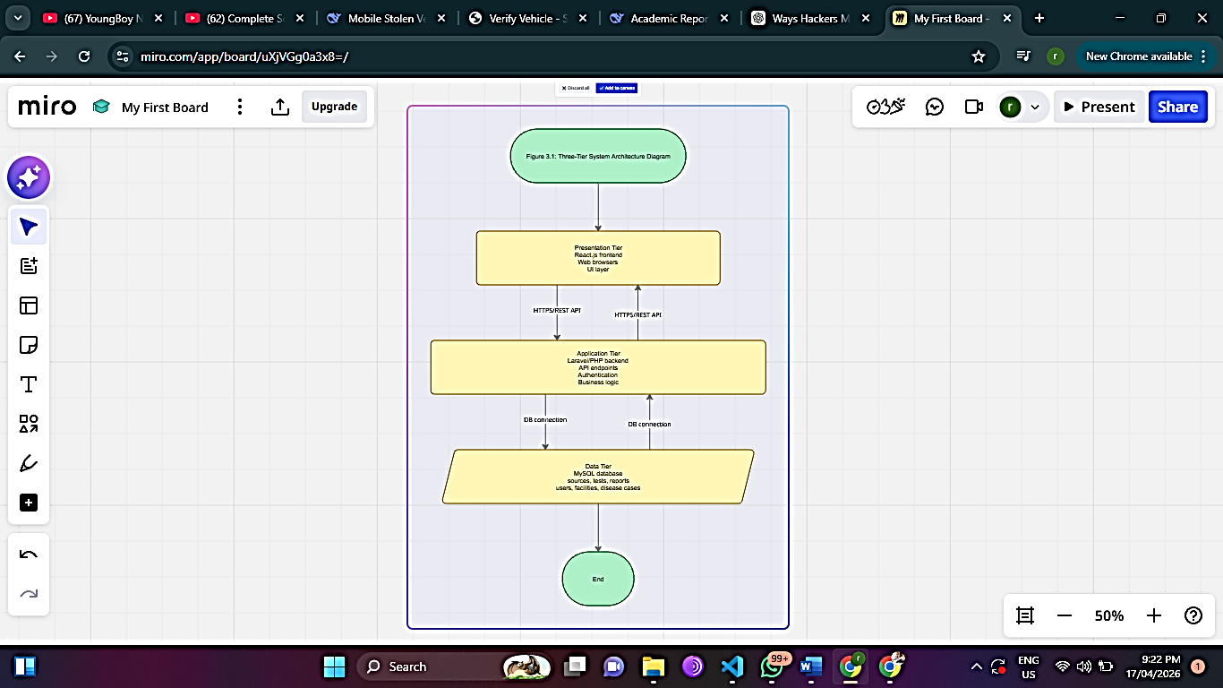

Figure 3.1: Three-Tier System Architecture Diagram showing the Presentation

3.4.2 Presentation Tier (Frontend)
The presentation tier is implemented using standard HTML, CSS, and vanilla JavaScript, chosen for their lightweight nature, compatibility with older devices, and suitability for low-bandwidth connections in Mankon. HTML provides the page structure, CSS handles responsive styling and color-coded status indicators, while JavaScript enables dynamic features such as fetching data from the API, updating the map, and submitting forms without page reloads. Key supporting libraries include Leaflet for interactive mapping, the native Fetch API for HTTP requests, the History API for client-side routing, Chart.js for data visualizations, and Tailwind CSS for accelerated responsive styling. This stack requires no build tools, remains maintainable, and deploys easily on standard web hosting.

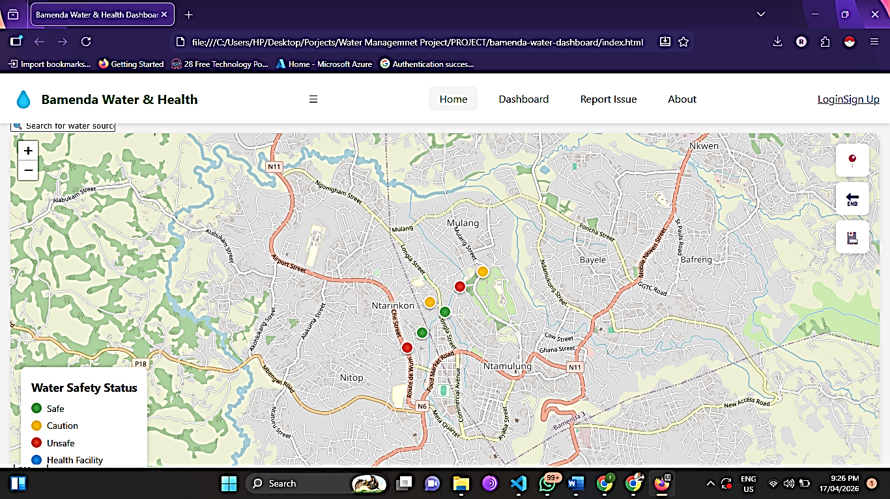

3.4.3 Application Tier (Backend)
The application tier handles business logic, authentication, data validation, and API request processing using PHP version 8.1 with the Laravel framework. Laravel was chosen for its robust features including Eloquent ORM for secure database interactions, built-in JWT authentication for session management, validation rules for data integrity, middleware for security filtering, and API resources for consistent JSON responses. The backend exposes a RESTful API organized by resource type. Authentication endpoints manage user registration, login, logout, and password reset. Water sources endpoints support retrieval with filtering and detailed views. Test results endpoints allow adding and retrieving historical test data. Community reports endpoints enable public submission and administrative moderation. Health facilities and disease cases endpoints support health data retrieval and submission, while user management endpoints are restricted to administrators. This RESTful design follows standard HTTP conventions, is stateless for scalability, and is widely documented

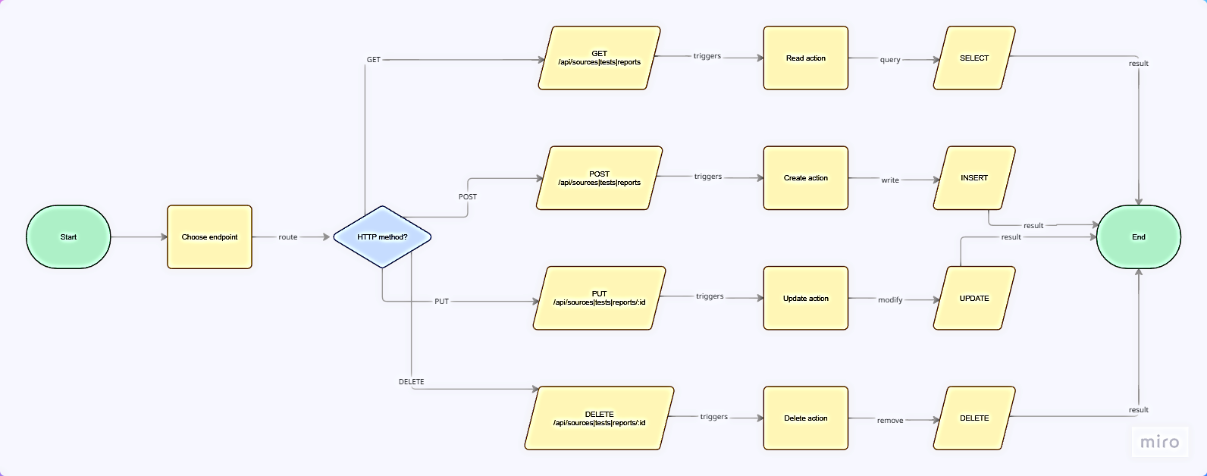

Figure 3.2: API Endpoint Structure Diagram showing the relationship between HTTP methods

3.4.4 Data Tier (Database)
The data tier is implemented using MySQL version 8.0, which runs locally through the XAMPP server environment. XAMPP was chosen as the development server because it provides a complete, ready-to-use web server package that includes Apache, MySQL, PHP, and phpMyAdmin, allowing the database to be easily managed through a graphical interface. MySQL itself is a reliable open-source relational database management system selected for its wide availability on hosting platforms, strong performance for read-heavy workloads typical of web applications, full ACID transaction support for data integrity, and seamless integration with the Laravel framework through Eloquent ORM. The database schema applies key design principles including normalization to third normal form for reduced data redundancy, referential integrity through foreign key constraints, strategic indexing on frequently queried columns for fast response times, and audit fields such as created_at and updated_at timestamps on all tables for tracking data changes.
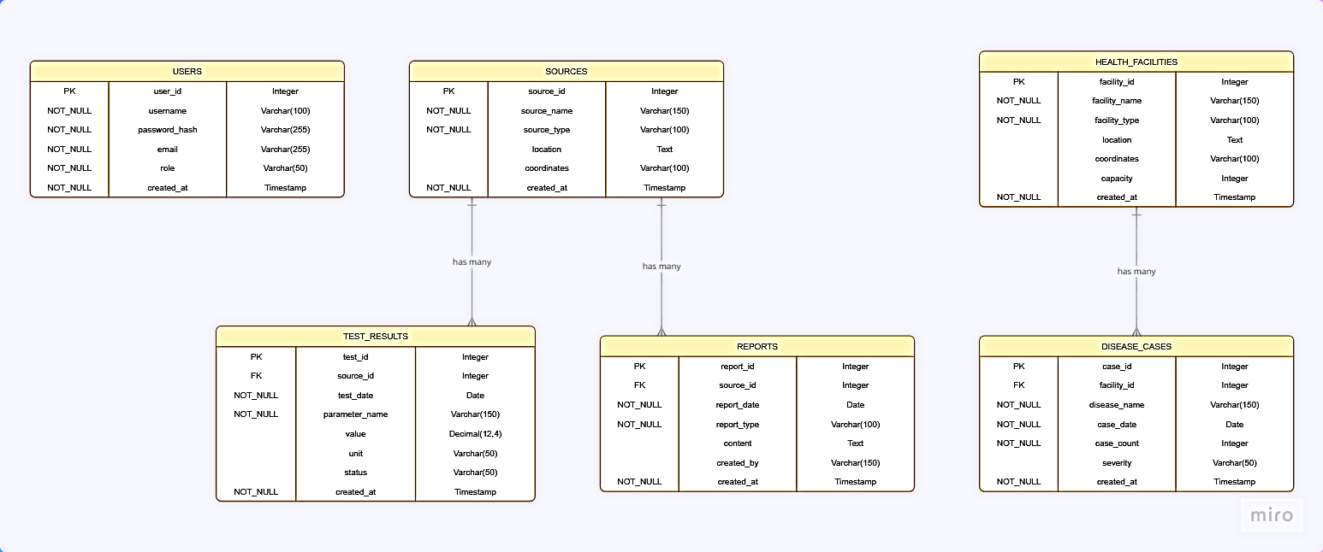

Figure 3.3: Entity-Relationship Diagram showing the six main tables

3.5 Database Design

3.5.1 Table Structures
The database comprises six core tables that support all system functionalities. The users table stores authentication credentials and role assignments including admin, data_entry, health_worker, registered, and anonymous. The sources table captures water source information such as name, GPS coordinates, source type, and current safety status indicated by green, yellow, red, or gray, along with a foreign key linking to the user who created the record. Two tables handle data collection: the test_results table stores official water quality tests with fields for test date, pH level, turbidity, coliform presence, and testing organization, while the reports table captures community observations with a moderation status field tracking pending, approved, or rejected reports.
The remaining two tables support public health integration. The health_facilities table stores locations of clinics and hospitals in Mankon with names, GPS coordinates, and facility types. Linked to this is the disease_cases table, which records weekly statistics for typhoid, diarrhea, and cholera cases per facility. All tables include primary keys, foreign key constraints for referential integrity, and timestamp fields for audit tracking. This relational structure enables the system to connect water quality data with public health outcomes, allowing users to visualize correlations between contaminated water sources and disease incidence in surrounding communities.

3.6 User Interface Design

3.6.1 Design Principles
The user interface design follows five guiding principles. The mobile-first principle prioritizes small screens starting at 320 pixels, then enhances for larger displays using responsive breakpoints, recognizing that smartphones are the primary internet access device in Mankon. The simplicity principle ensures each screen shows only information relevant to the user's current task, with complex features hidden behind progressive disclosure based on role permissions to prevent information overload. The consistency principle applies uniform patterns across the application, including standardized color coding where green indicates safe, yellow indicates caution, red indicates unsafe, gray indicates no data, and blue indicates health-related information, alongside consistent button styles, form layouts, and navigation structures.
The feedback principle requires immediate visual confirmation for user actions, such as loading spinners during form submission followed by success or error messages, as well as hover effects and popup animations for map interactions. The accessibility principle ensures color is never the sole means of conveying information, with text labels accompanying colored pins. Touch targets measure at least 44 by 44 pixels, exceeding mobile accessibility recommendations, while the application incorporates ARIA labels and semantic HTML to support screen reader users.

3.6.2 Color Scheme
The color scheme is carefully chosen to communicate meaning intuitively across the application. Green, with hex code 10B981, represents safe water and success messages. Yellow, hex code F59E0B, indicates caution and warnings. Red, hex code EF4444, signifies unsafe conditions, errors, and alerts. Gray, hex code 6B7280, denotes no data or disabled states. Blue, hex code 3B82F6, identifies health facilities and informational content. The primary brand color is a deep green, hex code 059669, used for buttons, links, and active navigation elements. Background color is a light gray, hex code F9FAFB, providing contrast without being harsh on the eyes. Primary text is dark gray, hex code 111827, while secondary text is lighter gray, hex code 6B7280.

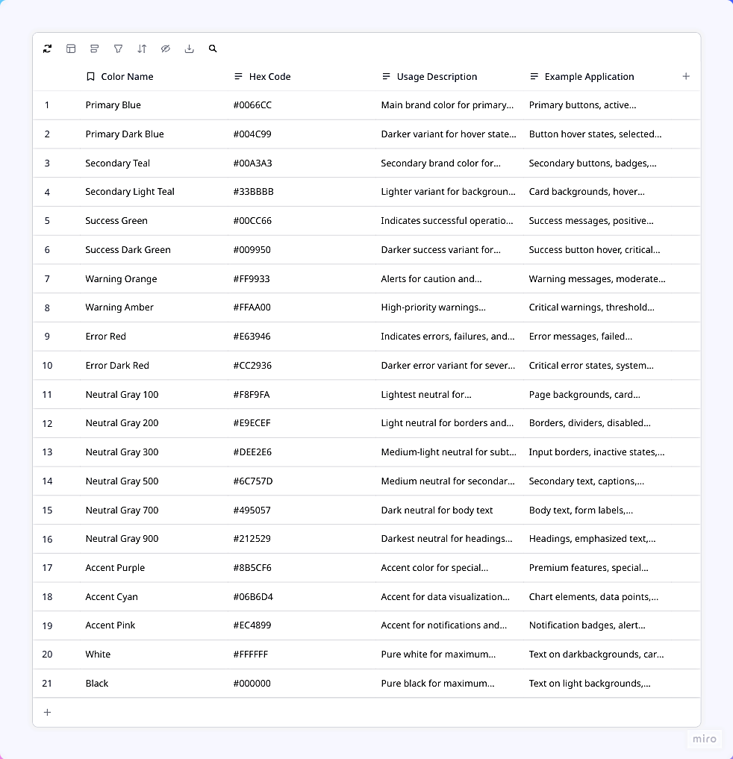

Table 3.1: Color Scheme Reference showing each color name, hex code

3.6.3 Screen Designs and Wireframes
The home page serves as the primary interface, featuring an interactive map with color-coded pins for each water source in Mankon, accompanied by a legend, filter controls for safety status and source type, a search box, and a statistics bar showing summary counts. When a user clicks on a pin, the water source detail page appears displaying comprehensive information including a prominent safety status badge, a photo gallery, a test results table showing historical official data in reverse chronological order, a community reports feed of approved observations, and action buttons for submitting new reports or adding official test results for authorized users.

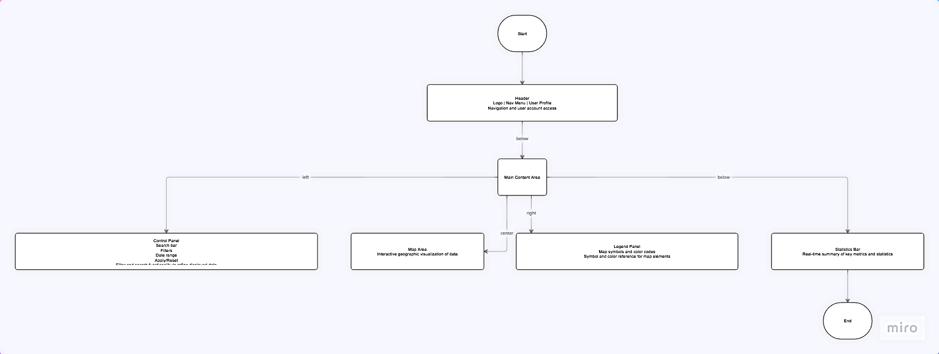

Figure 3.6: Home Page Wireframe showing the layout with header, map area, legend, control panel with filters and search, and statistics bar.
The community report form is a modal overlay with a dropdown for water source selection, icon-based radio buttons for observation type, and optional fields for details, name, and photo upload limited to five megabytes, with only source and observation type required to minimize participation barriers. The admin dashboard uses a tabbed interface organizing management functions into overview, sources, tests, reports, and users tabs, featuring statistics cards, activity logs, source management, test result entry, report moderation with approve and reject buttons, and user account management. Responsive breakpoints ensure adaptation across devices: on mobile below 640 pixels, a single-column layout with the map taking sixty percent of screen height, collapsed accordion legend, card-style tables, and hamburger navigation; on tablets between 640 and 1024 pixels, a two-column layout with compact visible legend; and on desktop above 1024 pixels, a multi-column layout with fully expanded legend and fixed control panel for constant access.

3.7 Processing Logic and Algorithms

3.7.1 Safety Status Calculation Algorithm
The safety status algorithm processes three data sources: the most recent official test result, the age of that test, and recent verified community reports. If no test result exists within the last six months, the status is set to gray indicating no data. If coliform is detected and the test is within three months, the status is set to red indicating unsafe. If coliform is detected but the test is older than three months, the algorithm proceeds to check community reports before a final determination. If no coliform is detected and the test is within three months, the status is provisionally set to green, but if three or more approved community reports from the last thirty days indicate concerning conditions such as cloudy water, bad smell, bad taste, or waste dumping, the status is downgraded from green to yellow. If the test is between three and six months old with no coliform detected, the status is set to yellow indicating caution due to stale data, and if the test is older than six months, the status is set to gray regardless of the result.

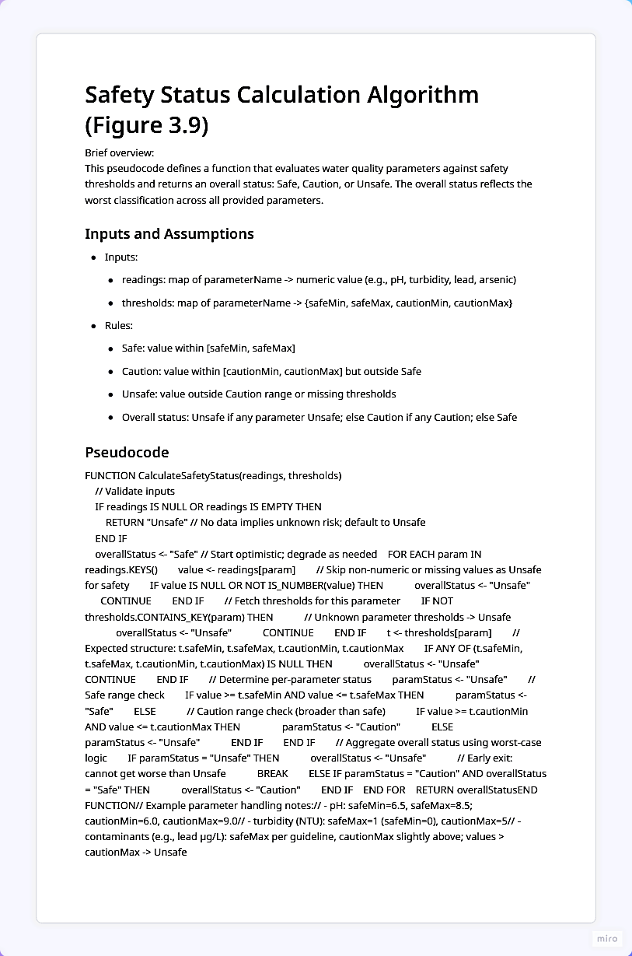

Figure 3.9: Pseudocode for Safety Status Calculation Algorithm showing the step-by-step logic in programming-like syntax.

3.8 Development Methodology

3.8.1 Selection of Agile Methodology
The project follows an agile development methodology with iterative cycles, specifically adopting a simplified version of Scrum suitable for a solo developer working within a bachelor's project timeframe. Agile was selected over traditional waterfall because requirements were expected to evolve as the design progressed, stakeholder feedback was valuable throughout development, and regular working software demonstrations provide better progress visibility than extensive documentation. The short iteration cycles allow for course correction if initial design decisions prove problematic.

3.8.2 Iteration Structure
Each iteration, or sprint, lasts one week and follows a consistent structure. Sprint planning at the beginning of the week selects features from the prioritized backlog based on dependencies and available time. Development occurs throughout the week with daily progress tracking against the plan. Testing is integrated into development, with each feature tested immediately after implementation rather than at the end of the project. A sprint review at the end of the week demonstrates working features, serving as a checkpoint for the project supervisor. A brief retrospective identifies what went well and what could be improved in the next sprint.

3.9 Development Tools and Environment

3.9.1 Hardware Environment
Development was conducted on a laptop computer with an Intel Core i5 processor, sixteen gigabytes of RAM, and a five hundred twelve gigabyte solid-state drive. This configuration provided sufficient performance for running the local development server, database, and frontend build tools simultaneously. Testing was performed on physical mobile devices including an Android smartphone with a six point one inch screen and an iPhone with a five point eight inch screen to verify responsive behavior and touch interactions.

3.9.2 Software Development Tools
The development environment was configured to match production using Ubuntu 22.04 LTS as the operating system, Apache 2.4 as the web server, PHP 8.1 with extensions for PDO database connectivity, OpenSSL encryption, and GD image processing, MySQL 8.0 as the database, and Node.js 18 for frontend build processes. Version control was managed through Git with a private GitHub repository, organized with a main branch for stable code and feature branches merged only after testing completion. Visual Studio Code served as the integrated development environment with extensions for PHP debugging, ESLint for JavaScript quality, Prettier for code formatting, and Tailwind CSS IntelliSense, while TablePlus provided graphical database management for viewing data, running queries, and inspecting table structures.

3.9.3 Technology Stack Summary
Layer | Technology | Version | Justification for Selection
Frontend | HTML5 | - | Provides semantic structure for all pages, supports accessibility features (ARIA labels), and ensures cross-browser compatibility
Frontend | CSS3 | - | Enables responsive design through media queries, supports modern layouts with Flexbox and Grid, and allows custom styling for color-coded status indicators
Frontend | Vanilla JavaScript | ES6+ | Requires no build tools or compilation, works reliably on older devices, reduces bandwidth usage, and is universally supported across all modern browsers
Frontend (Charts) | Chart.js | 4.4.2 | Simple to implement with vanilla JavaScript, lightweight compared to alternatives, and provides responsive, accessible charts for dashboard visualizations
Frontend (Styling) | Tailwind CSS | 3.4.3 | Utility-first approach accelerates development, enables responsive design without custom CSS, and purges unused styles for small production bundles
Backend | PHP | 8.1 | Widely supported on low-cost hosting platforms, has excellent documentation, and integrates seamlessly with MySQL through PDO
Database | MySQL | 8.0 | Reliable open-source RDBMS with ACID compliance, supports foreign key constraints, has strong performance for read-heavy workloads, and integrates seamlessly with Laravel Eloquent
Development Server | XAMPP | 8.2.x | Provides complete local web server environment (Apache, MySQL, PHP, phpMyAdmin) in a single package, simplifying development setup
Version Control | Git | 2.40+ | Enables change tracking, allows branching for feature development, provides backup through remote repositories, and supports collaboration
IDE | Visual Studio Code | 1.85+ | Lightweight yet powerful editor with extensive extension ecosystem, built-in terminal, Git integration, and excellent PHP/JavaScript support

Table 3.3: Complete Technology Stack showing each layer (Frontend, Backend, Database, Tools), the specific technology chosen, version number, and justification for selection.

3.10 Ethical Considerations

3.10.1 Data Privacy and Protection
Several ethical considerations guide the design and operation of the system to protect user privacy and ensure responsible data handling. Community report submissions allow anonymity because the name field is optional, encouraging participation from residents who may be concerned about identification or reprisal for reporting problems with community water sources. User accounts store minimal personal information including only name and email address, reducing the potential harm of any data breach. No sensitive health data is collected at the individual level because disease data is aggregated by facility rather than by patient, making re-identification impossible. Users can request deletion of their account and associated data at any time through the account settings page, and such requests are fulfilled within seven days.

3.10.2 Informed Consent
Informed consent is obtained through a consent statement presented during account registration. This statement explains in clear, non-technical language what data is collected, how the data will be used including display on the public map and dashboard, who can access the data including anonymous public users for approved reports, and users' rights regarding their data including access, correction, and deletion. By completing registration, users indicate their understanding and agreement to these terms. For anonymous report submissions that do not require registration, a shorter consent statement is presented above the submit button, explaining that submitted data will be publicly visible after moderation and that no identifying information will be collected unless the user chooses to provide it.

3.10.3 Data Accuracy and Transparency
Data accuracy is promoted through clear labeling of data sources and verification processes. Community reports are clearly labeled as unverified until moderated, with a "pending verification" badge visible to all users. Official test results are clearly distinguished from community reports through separate sections on the water source detail page and through visual styling including a "verified" badge. Simulated demo data used for demonstration purposes is clearly labeled as simulated with a prominent notice on the dashboard, preventing confusion with real data. These transparency measures help users make informed judgments about the reliability of information they see in the system and build trust in the platform.

3.11.1 Use Case Diagram
The use case diagram identifies five external actors and their interactions with the system. Local residents can view the map, view source details, and submit reports. Registered users gain additional dashboard access and report history. Data entry clerks can add test results and manage water sources. Health workers can submit weekly disease case data. Administrators have full system access including user management and report moderation. The diagram shows that viewing and reporting functions are widely available while data management functions are restricted by role.
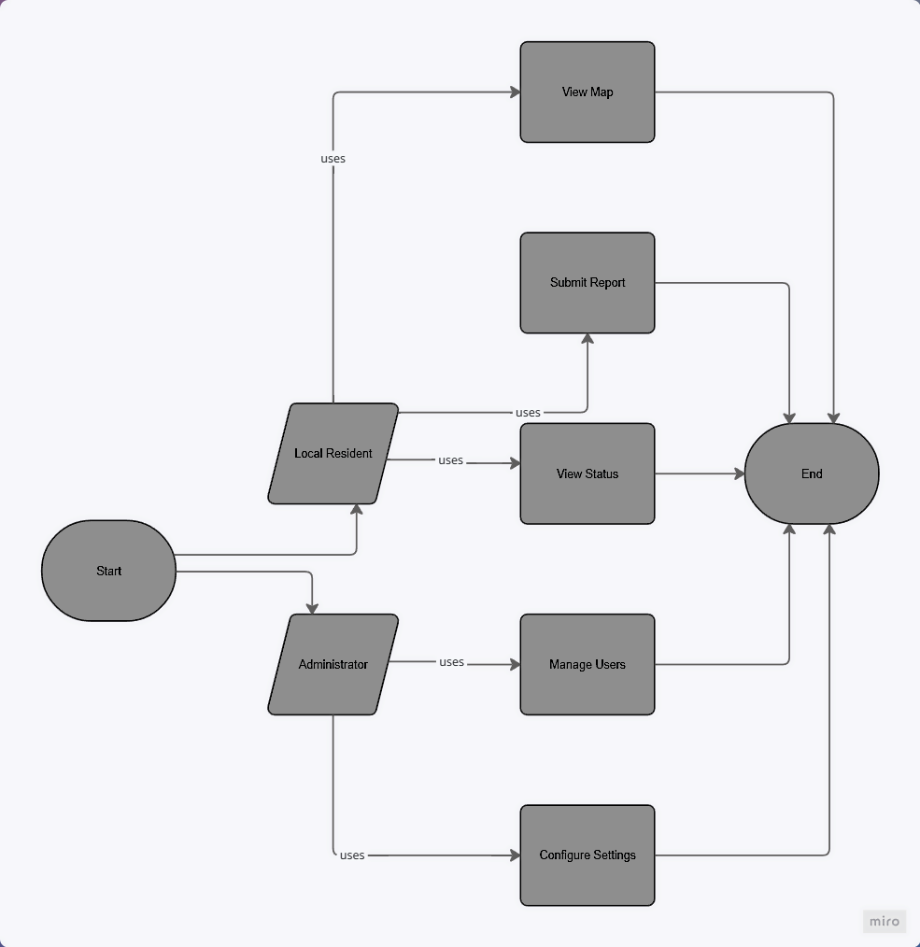

Figure 3.11: Use Case Diagram showing all five actors (Local Resident, Registered User, Data Entry Clerk, Health Worker, Administrator)

3.11.2 Class Diagram
The class diagram represents the static structure of the system with six main classes corresponding to the database tables: User, WaterSource, TestResult, Report, HealthFacility, and DiseaseCase. The diagram shows attributes and methods for each class, along with relationships indicating that one water source can have many test results and many reports, while one health facility can have many disease case records.

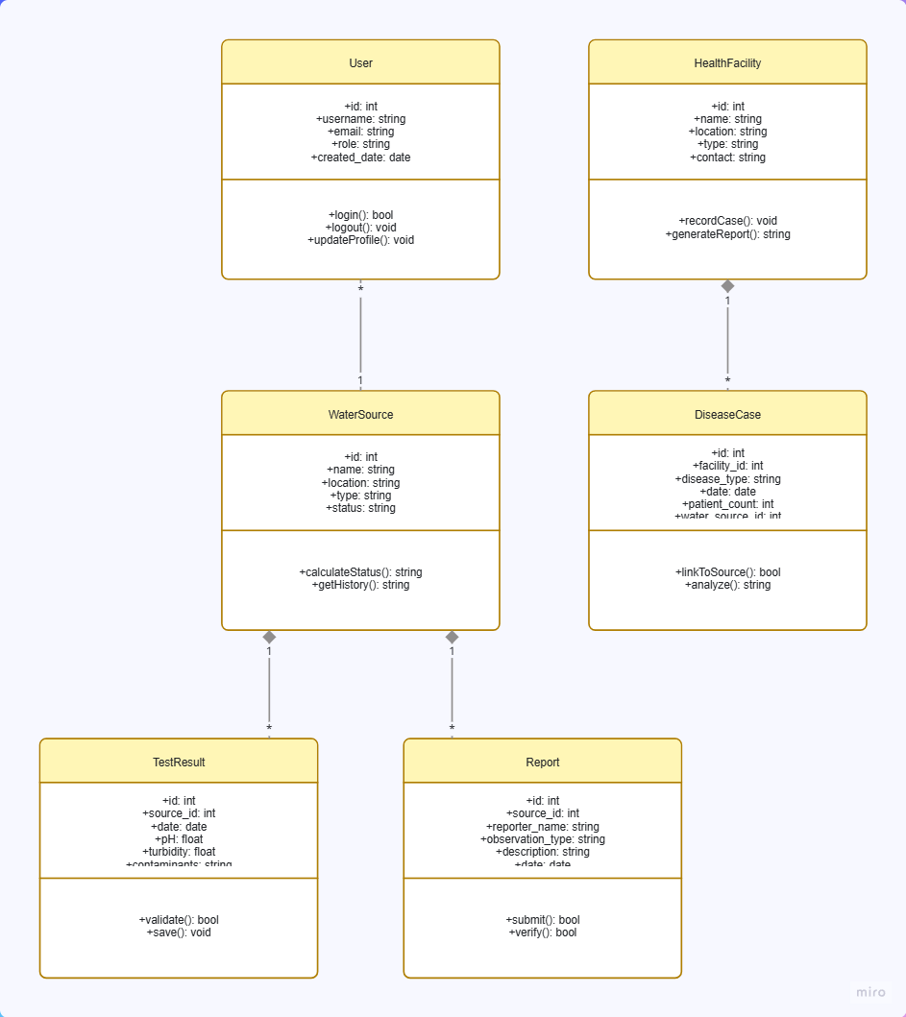

Figure 3.12: Class Diagram showing the six main classes with their attributes and methods, along with association lines indicating relationships and multiplicities

3.11.3 Entity Relationship Diagram
The entity relationship diagram provides a database-level view showing tables as entities, columns as attributes, and foreign key relationships as connections using crow's foot notation. The diagram illustrates that test_results and reports both reference sources, reports optionally references users, disease_cases references health_facilities, and sources references users through the created_by field.

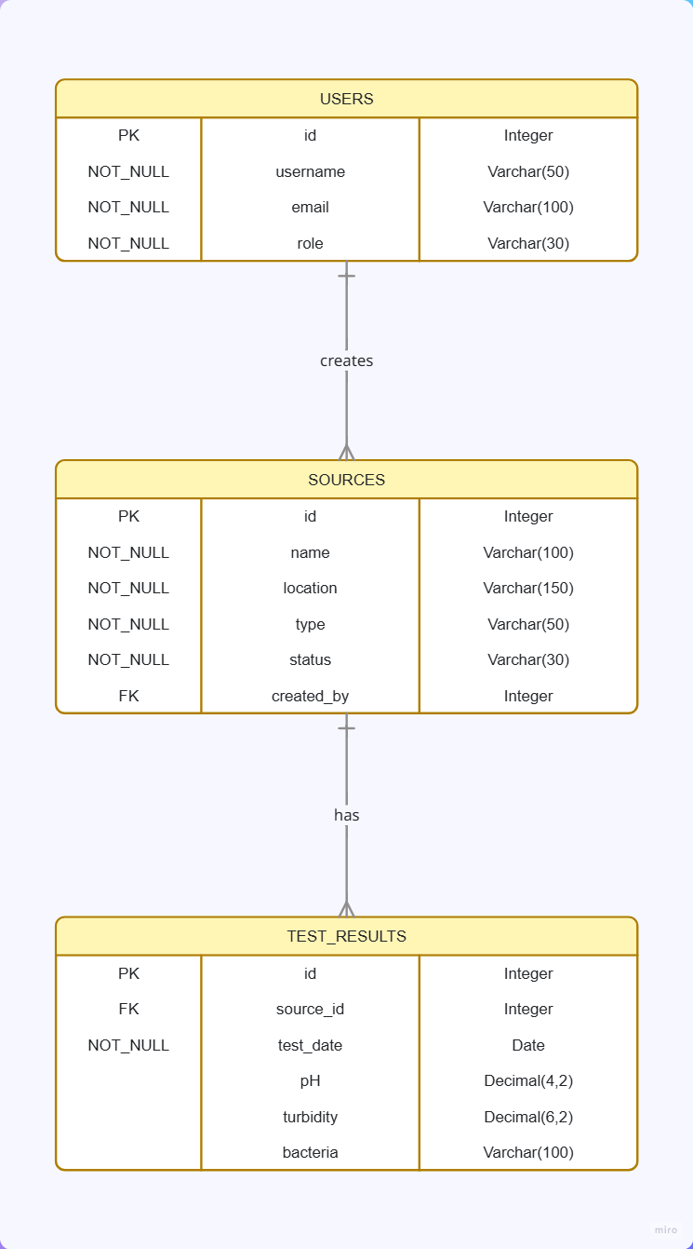

Figure 3.13: Entity Relationship Diagram showing the six tables

3.12 Summary
This chapter has presented the complete research methodology and system design for the Bamenda Water & Health Dashboard. The study adopts a design science research methodology, which is appropriate for creating and evaluating a technological artifact to solve a real-world problem. Requirements were gathered through document analysis, stakeholder analysis, and contextual inquiry, resulting in a comprehensive set of functional and non-functional requirements.
The system follows a three-tier architecture with a React.js frontend for the presentation tier, a Laravel PHP backend for the application tier, and a MySQL database for the data tier. The database design includes six main tables supporting water sources, test results, community reports, users, health facilities, and disease cases, with careful attention to relationships, indexing, and status calculation logic.
The user interface design follows mobile-first principles with color-coded map pins for intuitive communication of water safety status. Wireframes for the home page, detail page, report form, and admin dashboard provide a visual blueprint for implementation. The development methodology is agile with four phases spanning eight weeks. The technology stack is clearly defined with specific versions and justifications. The testing strategy covers unit, integration, system, and user acceptance levels with defined test cases. The deployment plan specifies hosting requirements and step-by-step deployment procedures. Ethical considerations address data privacy, informed consent, and transparency.

REFERENCES
Mofor Nelson Alakeh, Mbene Kenneth, Njoyim Estella Buleng Tamungang, Nchofua Festus Biosengazeh, & Nkemajen Eugene Asongafac. (2023). Domestic water quality assessment in Nteingue community, West Region of Cameroon. American Journal of Water Resources, 11(3), 88–97.
Triantafyllou, A. G., Evagelopoulos, V., & Zoras, S. (2006). Design of a web-based information system for ambient environmental data. Journal of Environmental Management, 80(3), 230–236.
Calvo-Brenes, G., & Salazar-Cespedes, K. (2023). Community water monitoring strategy for the Jorco river micro-basin based on the analysis of physicochemical, microbiological and biological indicators of water quality. Tecnologia En Marcha, 36(4).
Wieringa, R. J. (2014). Design science methodology for information systems and software engineering (1st ed.). Springer Berlin Heidelberg.
Chapman, D. V. (2021). Water quality assessments: A guide to the use of biota, sediments and water in environmental monitoring (2nd ed.). CRC Press.
Bartram, J., & Ballance, R. (2020). Water quality monitoring: A practical guide to the design and implementation of freshwater quality studies and monitoring programmes. CRC Press.
Moe, C. L., & Rheingans, R. D. (2021). Global challenges in water, sanitation and health. Journal of Water and Health, 19(2), 1–12.
Nkeng, G. E., Fonkou, T., & Mpakam, H. G. (2022). Challenges of water quality monitoring in Cameroon: A review. Journal of African Earth Sciences, 185, 104–118.
Chen, S., Zhang, Y., & Li, W. (2023). Web-based environmental monitoring systems: A systematic review. Environmental Modelling & Software, 159, 105–126.
Zhang, J., & Li, X. (2022). Real-time water quality monitoring using web technologies. Water Research, 210, 117–129.
Johnson, M., & O'Brien, C. (2021). Mobile-first design for low-bandwidth environments. Journal of Web Engineering, 20(4), 112–135.
Conrad, C. C., & Hilchey, K. G. (2020). A review of citizen science and community-based environmental monitoring. Environmental Management, 65(3), 325–340.
Danielsen, F., Burgess, N. D., & Balmford, A. (2021). Community-based monitoring for environmental management. Conservation Biology, 35(5), 1421–1433.
UN-Habitat. (2021). Water and sanitation in cities: Global report on human settlements. United Nations Human Settlements Programme.
UNICEF. (2022). Water, sanitation and hygiene annual report 2022. United Nations Children's Fund.
Ministry of Public Health Cameroon. (2023). Cameroon public health surveillance report 2022-2023. Government of Cameroon.
Wolf, J., Johnston, R. B., & Hunter, P. R. (2021). Water quality and health: A systematic review and meta-analysis. International Journal of Environmental Research and Public Health, 18(8), 421–438.
Fewtrell, L., & Bartram, J. (2021). Water quality: Guidelines, standards and health. IWA Publishing.

